Roteiro de Recuperação – 6th grades G1 – Teachers Ameli /Andrea - 2017
English
Name:
#
1st term



Roteiro de Recuperação

Vocabulary: animals, things in a room, free time, music, What time is it, jobs, daily routine, daily activities, home, food and drink.

Grammar: imperatives and object pronouns, there is/ there are, can/can't, Present Simple ( Affirmative, questions and negative), Adverbs of frequency

Para estudar sugerimos que você:
- Refaça os exercícios do workbook online.
- Reveja as avaliações: parcial e trimestral

Atenção: para o dia da nossa aula, você deve trazer os exercícios já resolvidos!

Após ter usado as estratégias acima, faça uma relação das suas dúvidas para serem tiradas com a professora no dia da aula de recuperação.

Bons Estudos!
Teachers Ameli and Andrea

Open your books to page 35.
How do we form affirmative imperative sentences.
Start with a verb :
* GO TO THE DOOR.
* CLOSE THE WINDOW, PLEASE.
How do we form the negative imperative sentences.
Add DON’T to form the negative.
DON’T USE THE CELL PHONE.
DON’T SIT ON THE FLOOR.

Imperatives

- Use imperatives to give instructions and commands.

Complete the sentences below to form imperatives.
___________________ the computer.
___________________ your books to page 10.
___________________ to bring your homework tomorrow.

1) Rewrite the sentences- positive or negative.

a) Sing a song ! = ___Don’t sing a song!__________________________
b) Write your name ! =___Don’t write your name!__________________________
c) Talk quietly ! = _____Don’t talk quietly!________________________
d) Wash your hands ! = ___Don’t wash your hands!__________________________
e) Drink linden tea ! = _____Don’t drink linden tea!________________________
f) Don’t eat junk food ! = ___Eat junk food!__________________________
g) Don’t play football in breaks! = __Play football in breaks.___________________________
h) Don’t read magazines ! = ____Read magazines!_________________________
i) Don’t do your homework ! = __Do your homework!___________________________
j ) Don’t listen to music ! = ______Listen to music!_______________________

2) Think of imperative sentences to the places below. ( suggested answers)

a) bedroom

Clean your bedroom!
Make your bed!
Don’t put your shoes under the bed!

b) Kitchen

Turn off the oven!
Wash the dishes!

c) Library

Don’t listen to music!
Turn off your cell phones!
Be quiet!

d) Classroom

Close the door!
Open your book to page ____!

e) Restaurant

Order your food!
Don’t be rude to people!

Open your books to page 37. Read the information about there is / there are.

- We Use THERE IS a/an + Singular nouns.
There is a book on the table.

- We use THERE ARE some/ THERE ARE (number) + a plural noun.
There are two books on the table.

- There aren’t any books on the table.
- There isn’t a ball under the bed.

- Is there a book on the bed?
- Are there any chairs in the kitchen?

3) Complete the questions with Is there or Are there. Then complete the short answers.

a) ____Is there_____________a TV in your bedroom?

Yes, ____there is_______________________________

b) ___Are there (any)______________books in your backpack?

No, __there aren’t___________________________________

c) __Is there_______________ a poster in your bedroom?

No, _____there isn’t.________________________________

4) Pay attention to the picture below and write 10 sentences. Use There is, There are, There isn’t a, There aren’t any, There are some. (Suggested answers)

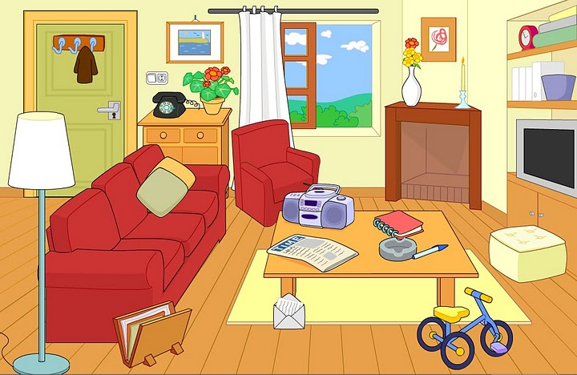

- _____There is a table in the livng room.
- __ There aren’t any people.
- ___There are some book s on the shelf.
- ___Thereisn’t a computer in the room.

5) Now work in pairs . Go back to the picture and ask and answer questions.

6) Complete the sentences with the correct form of there is/ there are.

a) ____There is _____ a tree in our garden.
b) _There is________ a girl called Tabatah in my class.
c) __There are_______ cows in the field.
d) __There are_______ some very big ships in the harbor today.
e) _There is________ fish for dinner.
f) _There is________ a girl in my class who can walk on her hands.
g) __There is_______ nothing to do when it rains.
h) __There is_______ cat sitting on the bench.
i) In our park ___there are______ some great things to play on.
j) In our park __there is_______ a fountain where we can drink water.
k) __There is_______ a computer in the classroom.
l) __There are_______ some posters in my office.
m) __There is_______ a CD player in my bedroom.
n) _There are________ 30 desks in the hotel.
o) ____There is _____ a blackboard in the classroom.
p) __There are_______ some dictionaries in the library.
q) __There are_______ some blue fish in the ocean.
r) __Is there_______ a tree in the field?
s) __Are there_______ any plants in that garden?
t) ____Is there_____ a cinema in my town?

7) Look at the picture and decide if each statement is true or false.

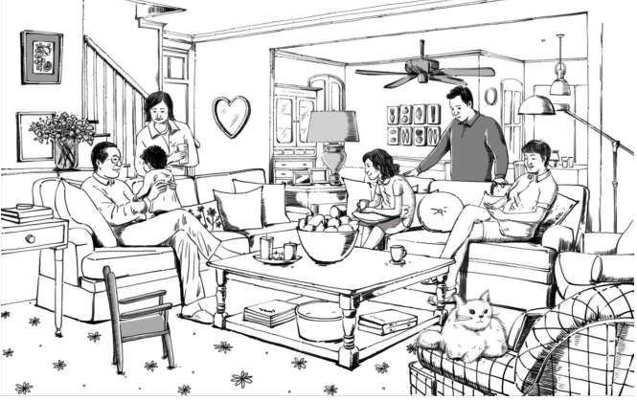

a) There are seven people in the picture. TRUE / FALSE
b) There is a cat on a chair. TRUE / FALSE
c) There is a woman standing behind a sofa. TRUE / FALSE
d) There aren’t any cups on the table. TRUE / FALSE
e) There are some books under the coffee table. TRUE / FALSE
f) There is a small chair in front of the coffee table. TRUE / FALSE
g) There aren’t any children in the living room. TRUE / FALSE
h) There are some flowers in front of a man. TRUE / FALSE
i) There is a fan in the picture. TRUE / FALSE
j) There is a small dog next to a chair. TRUE / FALSE

Open your book to page 45. Answer the questions below.

- When do we use can and can’t? To talk about abilities and things we have the time to do
- How do we form questions with can? __ We put can before the subject

- Answer the questions below. ( suggested answers)

- Can you play soccer? _____Yes, I can.___________________
- Can you speak Spanish? _____No, I can’t.___________________
- Can you drive a car? ____Yes, I can.____________________
- Can she play chess? __No, she can’t.______________________
- Can they use the playground? ___Yes, they can._____________________

8) Say what you can do or can’t do. Choose can or can’t according to you.
a) I __can’t____________ speak Chinese.
b) I ___can___________ sing very well.
c) I___can___________ run 20 kilometres.
d) I___can___________ ride a bicycle.
e) I__can____________ play basket.
f) I ___can___________ swim.
g) I ____can__________ understand my teacher of English.
h) I _____can’t_________ dance “sevillanas”.

9) Choose can or can’t according to the situation: Example: She can’t answer the phone now; she is not at home.
a) I know the answer; I _can_____________ answer the question now.
b) She is good at the piano; she____can__________ play the piano very well.
c) This test is very difficult; I __can’t____________ answer any question.
d) Maria can speak English but she___can’t___________ speak French.
e) You _can’t_____________ sleep today because you are very nervous.
f) Juan__can____________ play tennis very well; he is a good tennis player.

3. Write the following words in order:
a. milk can please I the have? Can I have the milk, please?
___________________________________________________________________________
b. school can’t to she go. She can’t go to school.
___________________________________________________________________________
c. languages can other speak she? Can she speak other languages?
___________________________________________________________________________
d. can’t he letter a write. He can’t write a letter.
____________________________________________________________________________
e. you under can’t water the run. You can’t water under the run.
_________________________________________________________________________
f. vegetarian she because meat eat she’s can’t a. She can’t eat meat because she’s a vegetarian.
_________________________________________________________________________
g. come on Sunday to they lunch can. They can come on Sunday to lunch.
_________________________________________________________________________
h. have we taxi a can? Can we have a taxi?
________________________________________________________________________

4. Write sentences about the people below. Write affirmative, negative and questions. ( suggestes answers)

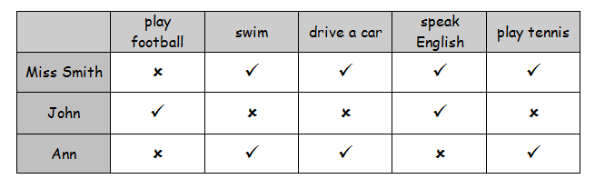

John can play football.
Ann can’t speak English.
_______________________________________________________________________________________________________________________________________________________________________________________________________________________________________

Circle the correct ideas. We use the SIMPLE PRESENT to talk about:
- daily routines
- activities that are happening now
- habits
- timetbales

SUBJECT + BASE FORM of the verb ( + -s with the third person singular)

- I get up at 6:00 o’clock.
- She gets up at 7:00 o’clock.

Go to page 57 on the student’s book and answer:
- How do we form Present Simple yes/no questions?
We use do for I, you, they and we.
We use does for he, she it.

- How do we form the Present Simple negative sentences.
We use don’t for I, you, they and we.
We use doesn’t for he, she it.

- Answer the questions below. ( suggested answers)

- Where do you live? ______I live in São Caetano. ________
- What do you do in the morning? __ I take a shower. ____
- Where does your mom work? __She works in a bank. ________________
- What does your dad do? ____He works in a company. He is a lawyer. _________
- What time do you get up? ___I get up at 7 o´clock. _____________________
- How do you get to school? ___I get to school by car. _____________________
- Does your mom drive a car? ___Yes, she does. ________
- Do your friends speak English? ___Yes, they do. ____

8) Write the 3rd person singular form of the verbs:
start ____starts________________
visit __visits__________________
go __goes___________________
listen __listens_________________
watch _watches____________________
read __reads____________________
like __likes_____________________
study __studies__________________

9) Use the Simple Present affirmative.
a) I __go______ (go) shopping with my brother.
b) We sometimes ___use_____ (use) a dictionary in class.
c) My friends ___study_____ (study) Italian at their school.
d) School _finishes_______ (finish) at three o´clock.
e) You _live_______ (live) near me.
f) He _likes_______(like) rap music.
g) She _does_______ (do) her homework before dinner.
h) We _play_______ (play) tennis in school on Wednesday afternoon.
i) I __watch______ (watch) TV in the evening.
j) My mother __teaches______ (teach) art.

10) Circle the correct answer :
a) I plays / play tennis every afternoon.
b) My parents live / lives in Ramat-Gan.
c) Tom listens / listen to the radio in the morning.
d) We eat / eats eggs for breakfast every morning.
e) My dog barks / bark at night.
f) Mrs. Gold sweep / sweeps the stairs once a week.
g) My brother never watches / watch television.
h) My family go / goes to the beach together in the summer.
i) I often eat / eats dinner at my grandmother’s house.
j) Sharon do / does her homework regularly.
k) They takes / take tests at school.
l) You usually listen / listens in class.
m) Dana and Liat goes / go to the swimming pool every afternoon.

11) What’s your routine like on…? ( students’ answers)

a) Wednesdays
__________________________________________________________________________________________________________________________________________________
b) Saturdays
__________________________________________________________________________________________________________________________________________________
c) Mondays
__________________________________________________________________________________________________________________________________________________

12) Lucy is talking about her family. Read the text and complete with the correct words in parentheses:

Hi! My name is Lucy. I ____________________ (live/lives) with my parents in Sydney, Australia. My mother’s name is Lilith and my father’s name is Fred. I _______________ (have/haves/has) two brothers and one sister. My brothers, Peter and Walter, ________________ (live/lives) with us, too. Peter ______________ (study/studies) in a school downtown. He _____________ (take/takes) the train to school. He ______________ (get up/gets up/get ups) at 6 am. That’s very early! But Walter ________________ (get up/gets up/get ups) late. He ______________ (walk/walks) to work. Peter ________________ (do/dos/does) his homework every day at 5pm. My sister, Helena, ________________ (live/lives) downtown with her husband, James. He __________________ (work/works) in the suburbs. They _________________________ (don’t take/doesn’t take/doesn’t takes) the bus to our house. They _______________ (go/gos/goes) to our house by car. James is a doctor, but he _________________ (don’t work/doesn’t work/doesn’t works) in a hospital, he ___________________ (work/works/workes) in an office. They ______________ (visit/visits/visites) us every Sunday. I really __________________ (love/loves) my family!
13) Unscramble the questions about Lucy’s family:

a) - __Does she live alone?______________________________?
(she/alone/does/live)
- No, she lives with her brothers and her parents.
b) - ___Where do they live?___________________?
(they/where/live/do)
- They live in Sydney, Australia.
c) - ____What does Helen’s husband do?__________________?
(Helena’s/does/do/what/husband)
- He’s a doctor.
d) - ___How does she like her family? __________________________?
(how/she/her/does/like/family)
- She loves her family!
e) - ___Does Peter walk to school___________________________?
(walk/does/Peter/to/school)
- No, he takes the train to school.

14) Complete the picture below with adverbs of frequency.

100%
Always
Usually
Often
Sometimes
Hardly ever
Never

0%

15) Put the words into the correct order.

1. homework/ usually / does / at / his / seven/he. He usually does his homework at seven.
______________________________________________________

2. is / sister / late / my / always / .My sister is always late.
______________________________________________________

3. the / go / sometimes / to / cinema / we/. We sometimes go to the cinema.
______________________________________________________

4. is / unhappy / James / never / .James is never unhappy.
______________________________________________________

5. always / are / they / friendly / .They are always friendly.
______________________________________________________

6.often / the / school / walk / to / children.The children often work tos chool.
______________________________________________________

7. after / usually / I / meet / friends / school / my. I usually meet my friends after school.
______________________________________________________

8. pizza / mum / never / my / makes / . My mum never makes pizza.
______________________________________________________

16) Come up with 5 questions to ask your friend. You can ask about people in his family, too. Use the Present Simple.

a) _____________________________________________________________________
b) _____________________________________________________________________
c) _____________________________________________________________________
d) _____________________________________________________________________
e) _____________________________________________________________________
17) Answer these questions. Write complete answers. ( suggested answers)

a) What do you always do on the weekend? I always go to the park. _________________________________________________________
b) What do you usually do in the evenings? I usually read a book. _________________________________________________________
c) What time do you usually get up in the mornings? I usually get up at 7:00
____________________________________________________________
d) Where do you often go after class? I often go home.
____________________________________________________________
e)Where do you sometimes eat lunch? I sometimes eat lunch at Gulah Gulah. _________________________________________________________
f) What do you always do in your free time? I always listen to music.
________________________________________________________

VOCABULARY

18) Complete the table below with: ( suggested answers)

animals | Things in a room | music | jobs | Daily routine
Dog  Cat  Pig  Horse | Bed  Table  Rug | Pop  Rock  Classical | Teacher  Doctor  Receptionist  Driver | Get up  Go to school  Have lunch  Have dinner  Take a shower

19) Ex. 1. Match the time.
1. It’s three o’clock. |  | a. 12.35
2. It’s a quarter past eight. |  | b. 8.05
3. It’s ten thirty. |  | c. 11.25
4. It’s five to five. |  | d. 1.58
5. It’s nine twenty five. |  | e. 8.15
6. It’s twenty-five to eleven. |  | f. 4.55
7. It’s two to two. |  | g. 10.35
8. It’s eleven twenty-five. |  | h. 9. 25
9. It’s five past eight. |  | i. 10.30
10. It’s twelve thirty-five. |  | j. 3.00

